Name: Kunal R. Chaudhari
Roll no: 57
Batch: TE - 3 - R
Assignment No 8 CNL
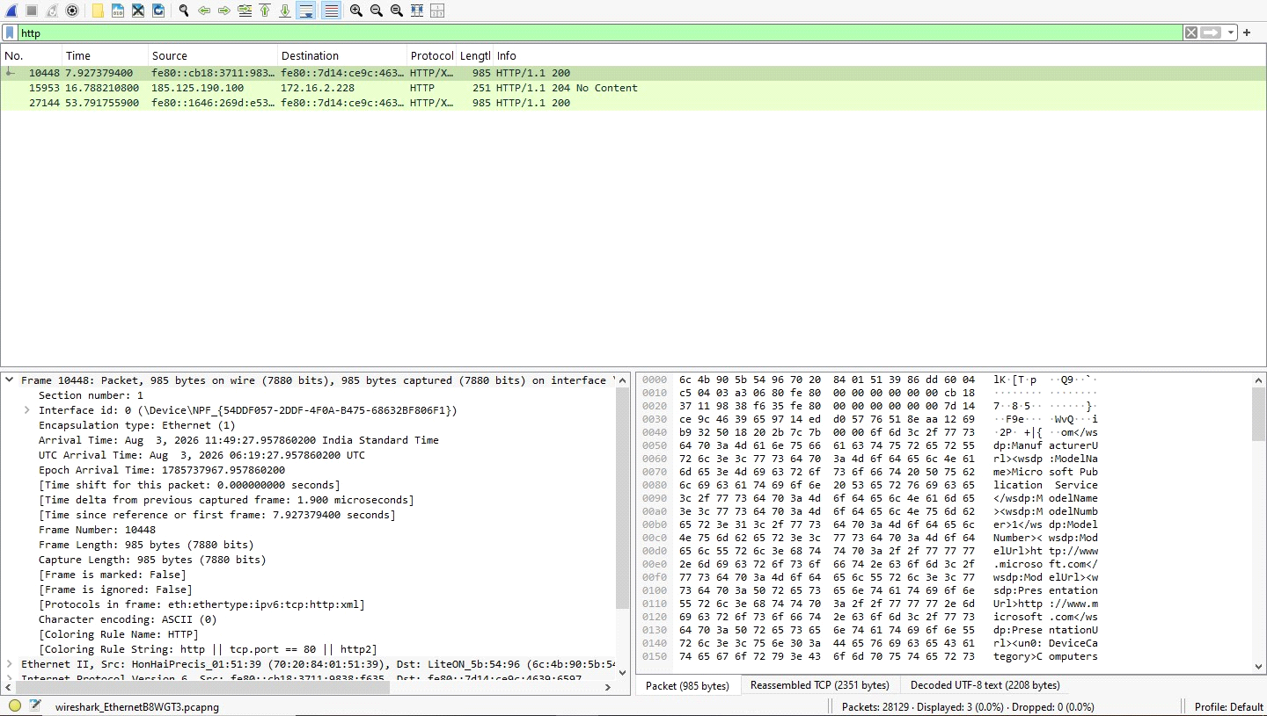
TCP Traffic
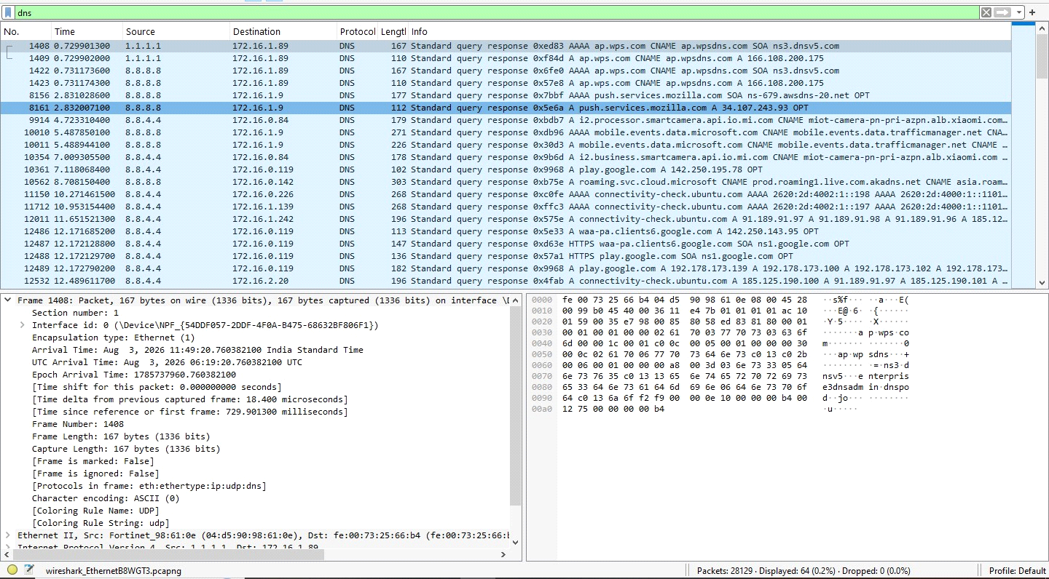
HTTP Traffic
Steps to start SMTP Locally
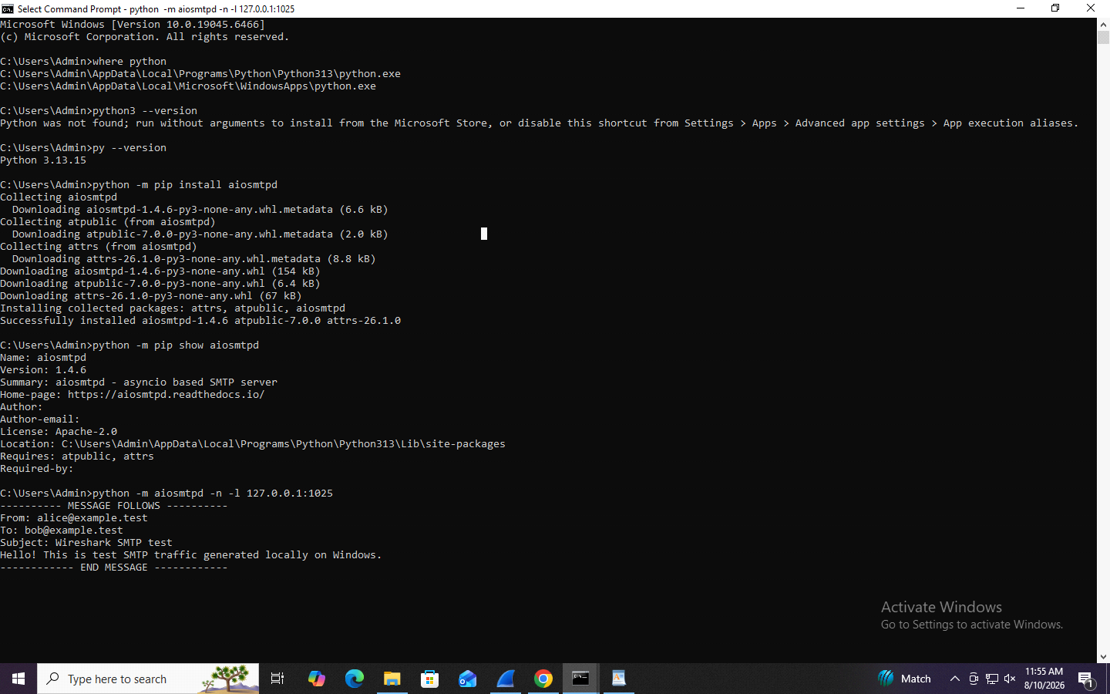

Write an Email to test the server
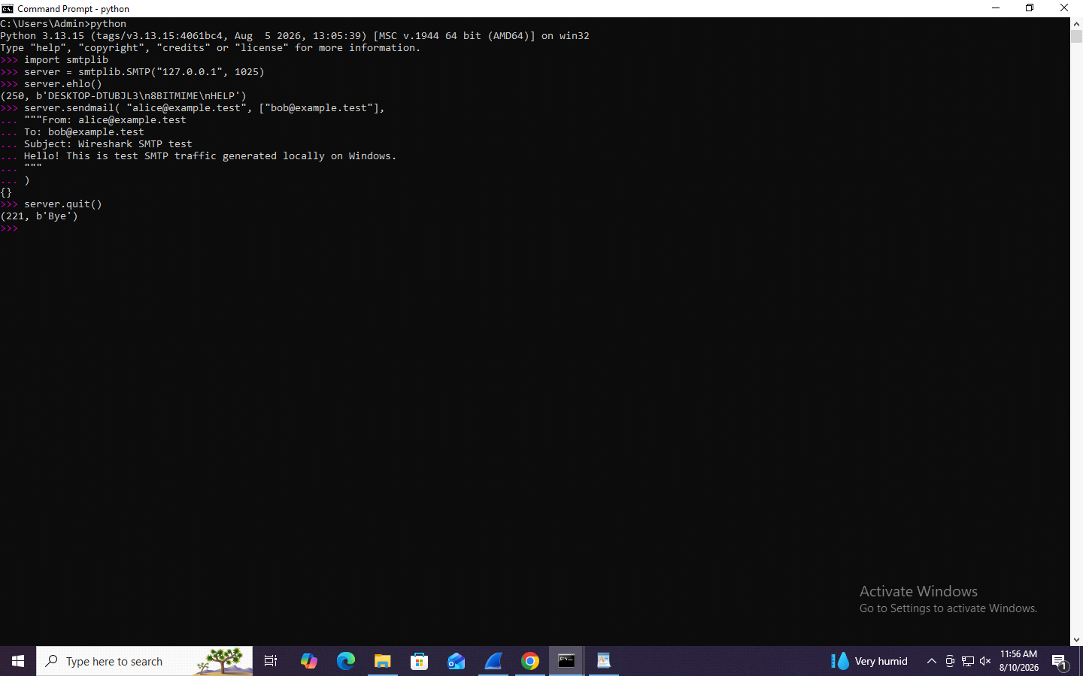

SMTP Traffic
